|  |  |  |
| --- | --- | --- |
|  | **Rochester Institute of Technology**  **Golisano College of Computing and Information Sciences**  **School of Interactive Games and Media**  **2145 Golisano Hall – (585) 475-7680** |  |

**Data Structures & Algorithms for Games & Simulation II**

**IGME 309**

**Bounding Space**

This exercise follows lecture D12

1. Under _Binary look for the example solution. It will look like this:

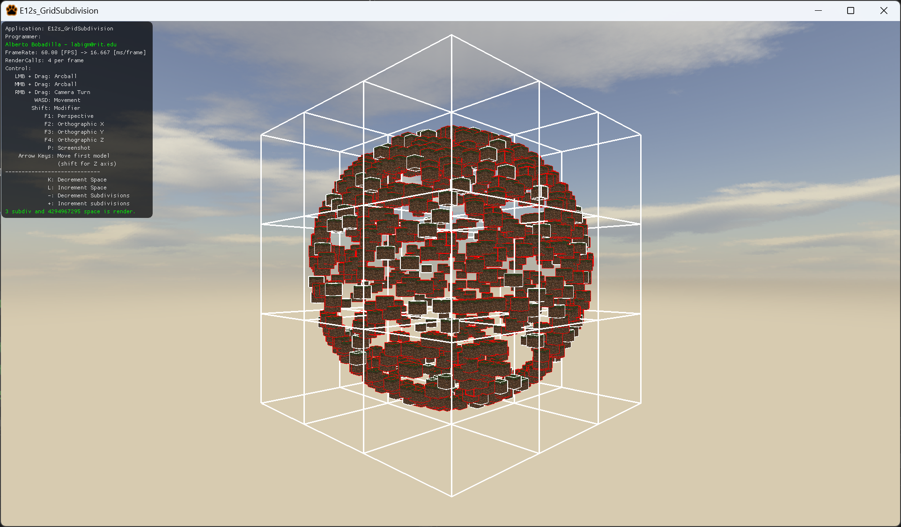

1. Out of the box the subdivision on the grid will be already functional, but the connection between the entities and the spaces is not. What you have to do in this exercise is implement the AssignIDsToEntities Method following the comments on the method.
2. This exercise only requires the Node.cpp file for submission.